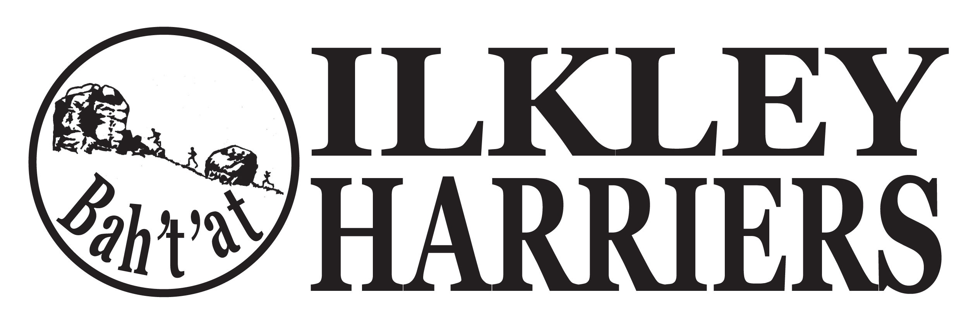
Committee Meeting

Agenda

7th November 2017

- Apologies

2. Minutes of Meeting 3rd October 2017

3. Matters arising

4. Running the Club:

4.1 Harrier and Volunteer of the month

4.2 Events: Upcoming: Predictor run proposal, Christmas relays and quiz, Annual Awards do

4.3 Membership update

4.4 Junior update

5. Developing the Club

5.1 Development plan

5.2 Junior facilities

6. AOB - Northern athletics proposal to charge £2pp and AGM

Next meeting proposed: 8:30pm on Tuesday 5th December 2017 at ILTSC

